TASK 3 Solutions

Q1 Solution

Display book and Add Book , view the added book in list

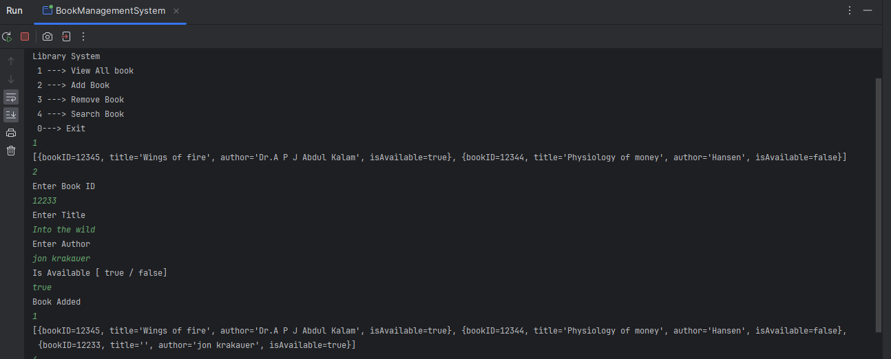

Search and remove book by bookID

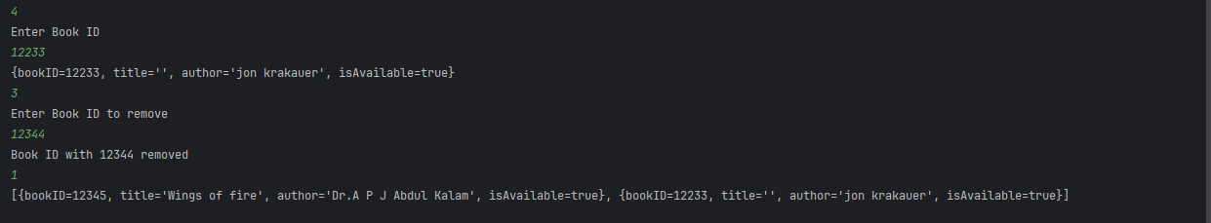

Q2 Solution

Employee tax and Product tax

